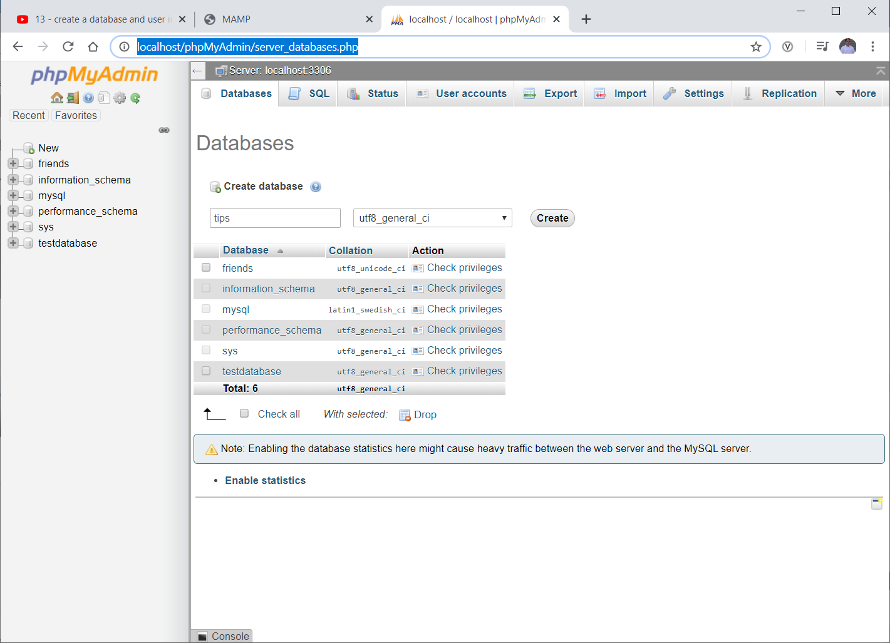

Hit Create

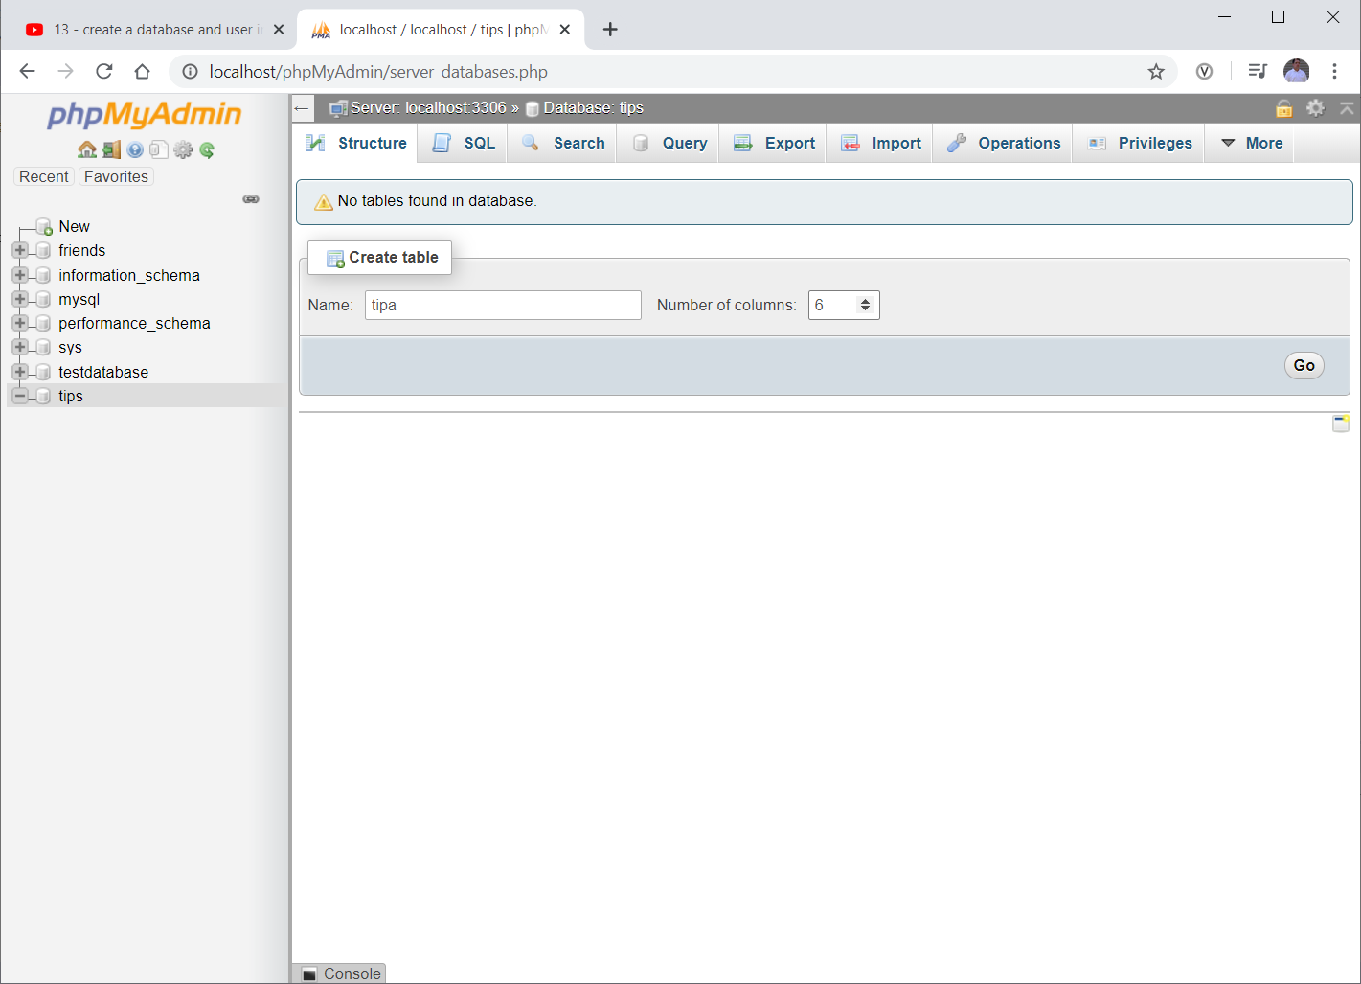

Hit GO

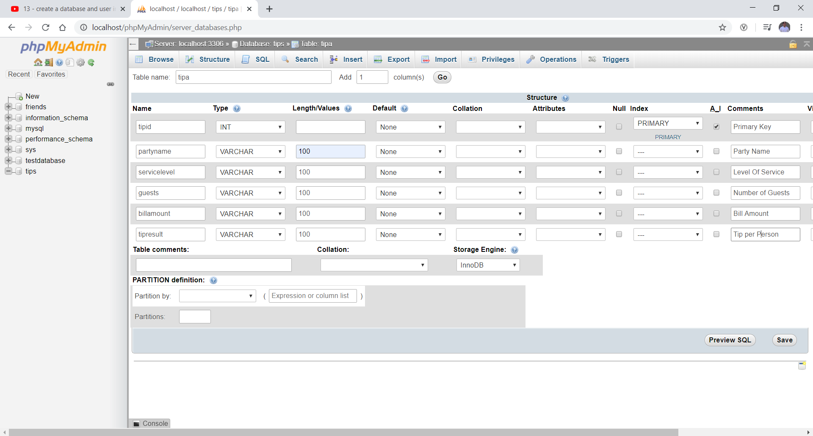

Hit Save

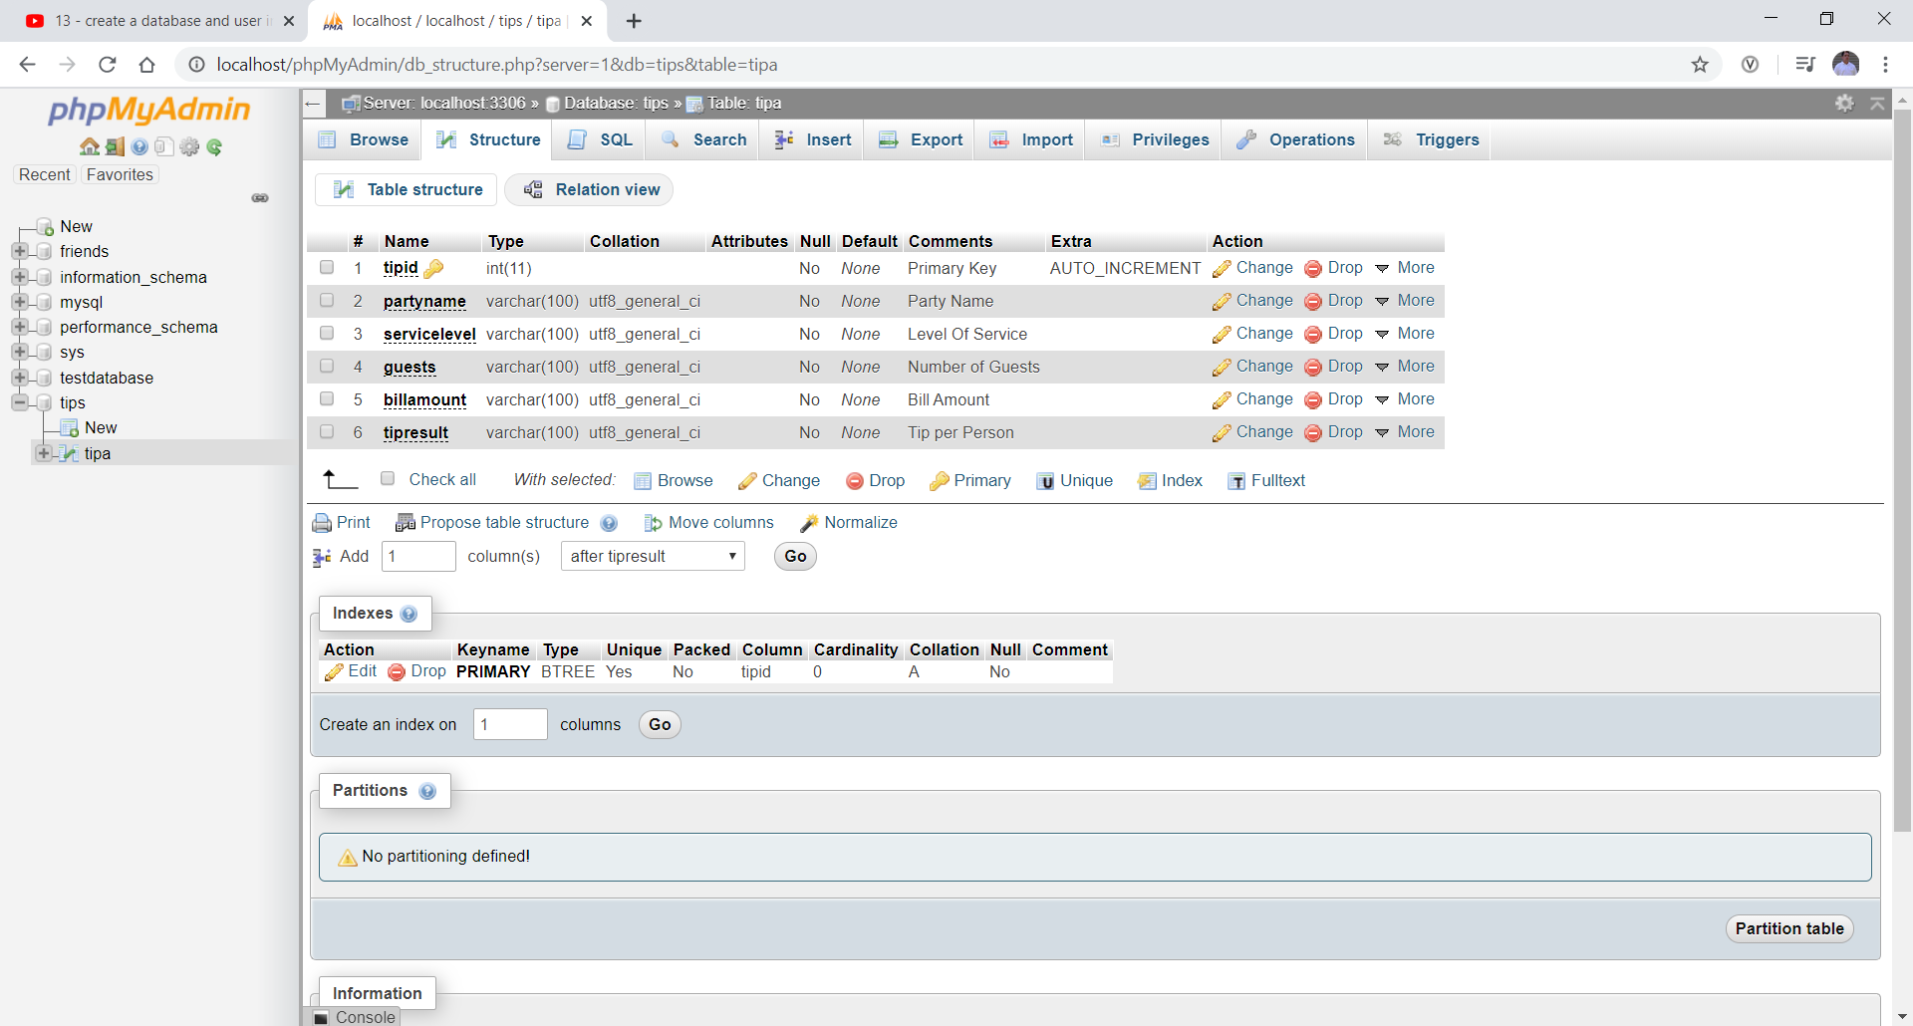

Results (above)

Hit Server Local Host

Hit User Accounts

Hit Add User

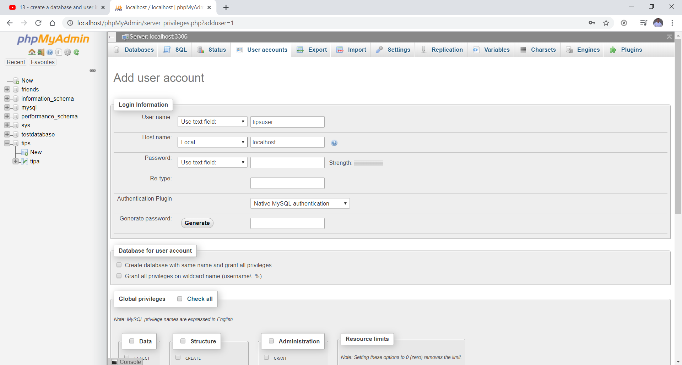

Change to local

PW – Hello123

Global privileges – check all

Hit Go – way at the bottom (scroll)

Create php file dbconnection.php